
“Give A Whoop!” Workshop
Saturday November 15, 2014
Lafayette Public Library, South Regional Branch

Name:

Primary Phone #: Alternate Phone #:

Email:

Home Address:

City: State: Zip:

School/Organization Name:

Special Dietary Needs:

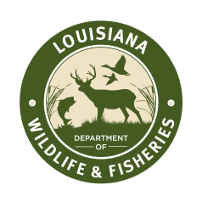

REGISTRATION FEE: $25.00
- This workshop fee will be refunded upon completion of the workshop.
- Please make checks payable to LDWF Foundation. Mail to:
Carrie Salyers
LDWF

102 Magnate Dr. Suite 201
Lafayette, LA 70508



